# Messages

## View Inbox

1. Log On to the System.

2. Click on the “Go to Message Centre” link at the top right of the page.

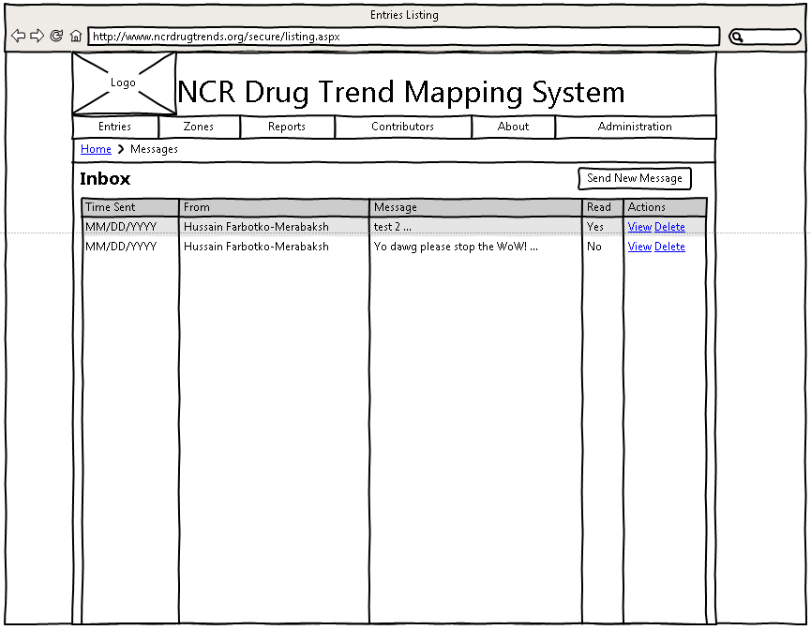

Figure : Message Centre

3. You will see a list of messages. Within this list you can click “View” to see the message in detail, or you can delete the message by clicking “Delete.”

## View a Message

1. From your inbox, click the “View” button on the message you want to read.

2. Enjoy your message!

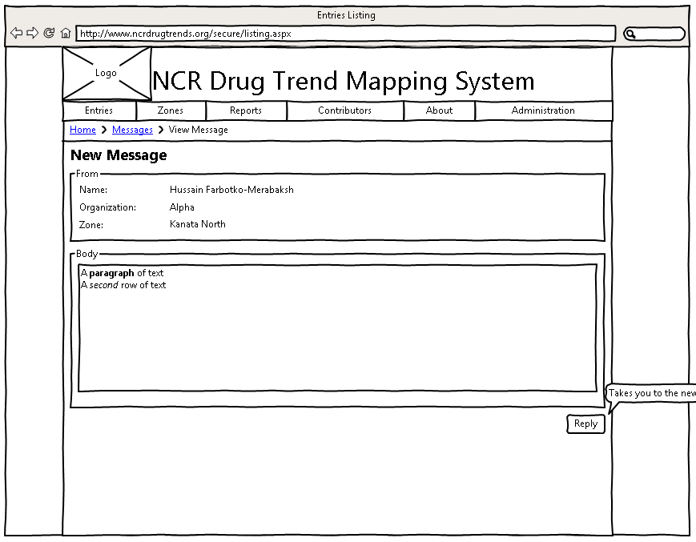

Figure : View Message

## Reply to a message

1. From the Message Centre, view the details of a particular message.

2. Click the “Reply” button.

3. Enter your message and click “Send” to send the message.



## Send a Message

1. From the Message Centre, click “Send New Message.”

2. Add a recipient to the message. This can either be a person, Organization, Zone, or Bulletin.

3. Enter your message, and click “Send” to send the message.

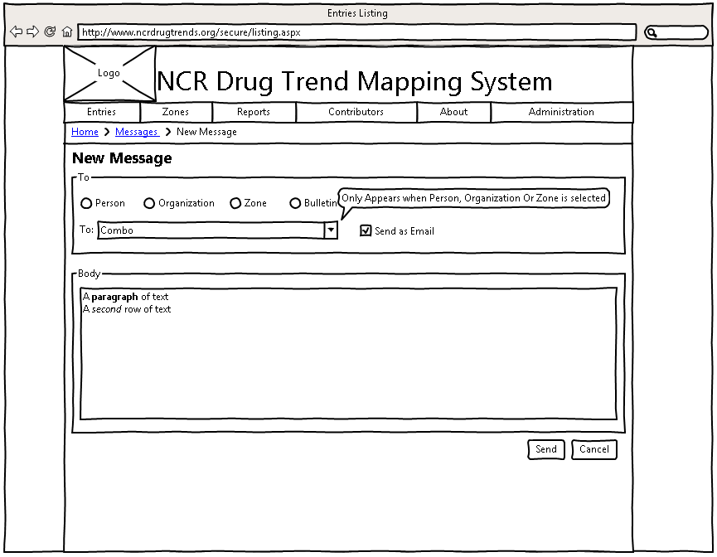

Figure : Send a Message